## Problem 3 – Login Form

Create a Web form (HTML5 + CSS3 + images) that looks and behaves like the screenshots below:

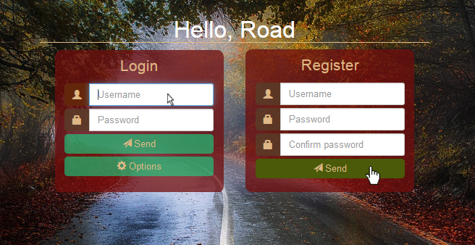

### Input

You are given the above screenshots + the background image.

### Output

The cursors in the screenshots demonstrate the form's behavior, do **NOT** implement them.

The output should be valid HTML5 + CSS3 + images that implement the above Web form.

### Constraints

* Main font: Tahoma, Helvetica, sans-serif.
* Main container for both forms must be 530 x 350px.
* Main container should be in the center of the Web page.
* The background image should cover the entire Web page.
* Form validation **is not required**.
* The site should open correctly in Chrome 35 and above.
* Responsive design **is not required**.
* Pixel-perfect implementation **is not required**.